DOKUMATASYON

SİSTEM ÖĞELER ÖZELLİKLER FAALİYETLER

ARAYÜZ KULLANICNIN KOLAY KULLANILABİLİR ARAYÜZ GERÇEKLEŞTİRİM ARAYÜZ

SİSTEM

İLETİŞİM MESAJ CİHAZLARI KISA YENİ HABER GÖNDERME

İLİŞKİLER

ZAMANSAL İLİŞKİSİ: ÜRÜN ÜZERİNDE ADMİN KISMI,İLETİŞİM , BELLİ ZAMANA BÖLÜP GERÇEKLEŞTİRİLİR.

NEDEN SONUÇ İLİŞKİSİ: ÜRÜN TALEP EDİLMESİ İÇİN BASİT KULANABİLİR ARAYÜZ KULLANILIYOR

AMACLAR

1.PAZARI GENİŞ BİR SİSTEM GERÇEKLEŞTİRMEK.

2.HERKESİN KULLANABİLECEĞİ BİR SİSTEM GERÇEKLEŞTİRMEK.

3.SİSTEMİ KULLANABİLİR HALE GETİRMEK.

|  |  |  |
| --- | --- | --- |
| 1.ALT SİSTEM | SİSTEMİN ADMİN KISMI GERÇEKLEŞTİRİLİR. | GÖNDERİLEN MAKALELERİNTUTULDUGU YER |
| 2.ALT SİSTEM | KULLANICI TARAFINI GERÇEKLEŞTİRMEK | KULLANICIN GERÇEKLEŞTİRECEĞİ ARAYUZ GERCEKLESTİRMEK |
| 3.ALT SİSTEM | HAKEM KISMINI GERÇEKLEŞTİRMEK | GÖNDERİLEN MAKALELERİNİN  BENZERLİK ORANINI BULMAK İÇİN KULLANILIR |

|  |  |
| --- | --- |
| ARAYÜZ GERÇEKLESTİRME | 1 AY |
| KODLAM İŞLEMİ | 1 AY |
| SÜRE | 2 AY |

KULLANILAN YAZILIM ARAÇLARI

.PHP,NETBEANS IDE2 EDİTORÜ,AJAX ,HTML,CSS,MYSQL,XAMP

SİSTEMİN GİRİŞ SAYFASI

.HTML VE CSS KULLANILMISTIR.

LOGİN SERVİSLER REGİST İŞLEMLERİ BULUNMAKTADIR.

KOLAY KULLANILIŞLI BİR ARAYUZE SAHİPTİR.

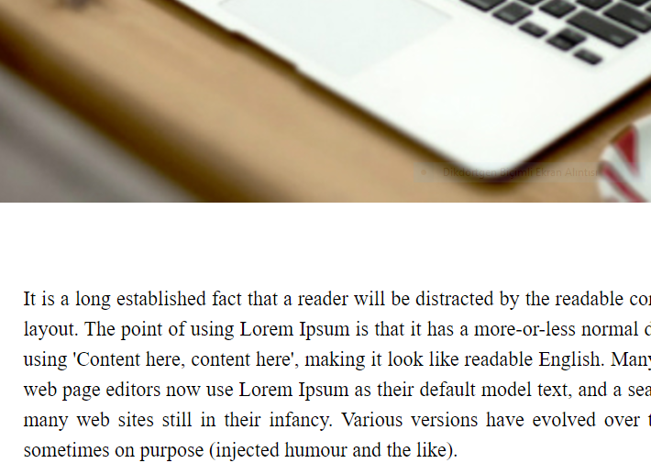

<html>

<head>

<title>Login</title>

<style>

body{

margin: 0;

padding: 0;

background: url(article.jpg);

background-size: cover;

font-family: sans-serif;

}

.title{

text-align: center;

padding: 50px 0 20px;

}

.title h1{

margin: 0;

padding: 0;

color: #262626;

text-transform: uppercase;

font-size: 36px;

}

.container{

width: 50%;

height: 400px;

background: #fff;

margin: 0 auto;

border: 2px solid #fff;

box-shadow: 0 15px 40px rgba(0,0,0,.5);

}

.container .left{

float: left;

width: 50%;

height: 400px;

background: url(article.jpg);

background-size: cover;

box-sizing: border-box;

}

.container.right{

float: right;

width: 50%;

height: 400px;

box-sizing: border-box;

}

.formBox{

width: 100%;

padding: 80px 40px;

box-sizing: border-box;

height: 400px;

background: #fff;

}

.formBox p{

margin: 0;

padding: 0;

font-weight: bold;

color:#a6af13;

}

.formBox input{

margin-bottom: 20px;

}

.formBox input[type="text"],

.formBox input[type="Password"]

{

border:none;

border-bottom: 2px solid #a6af13;

outline: none;

height: 40px;

}

.formBox input[type="text"]:focus,

.formBox input[type="Password"]:focus

{

border-bottom: 2px solid #262626;

}

.formBox input[type="submit"]{

border: none;

outline: none;

height: 40px;

color: #fff;

background: #262626;

cursor: pointer;

}

.formBox input[type="submit"]:hover{

background: #a6af13;

}

.formBox{

color: #262626;

font-size: 12px;

font-weight: bold;

}

</style>

</head>

<body>

<div class="title"><h1><Sign In Form</h1></div>

<div class="container">

<div class="left"></div>

<div class="right"></div>

<div class="formBox">

<form>

<p>Username</p>

<input type="text" name="" placeholder="online">

<p>Password</p>

<input type="Password" name="" placeholder="*****">

<input type="submit" name="" value="Sign In">

<br><br>

<a href="#" >Forget Password</a>

</form>

</div>

</div>

LOGİN İŞLEMİ

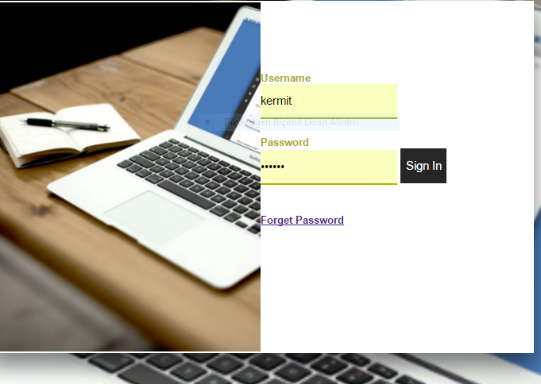

Login işlem code <html>

<head>

<title>Login</title>

<style>

body{

margin: 0;

padding: 0;

background: url(article.jpg);

background-size: cover;

font-family: sans-serif;

}

.title{

text-align: center;

padding: 50px 0 20px;

}

.title h1{

margin: 0;

padding: 0;

color: #262626;

text-transform: uppercase;

font-size: 36px;

}

.container{

width: 50%;

height: 400px;

background: #fff;

margin: 0 auto;

border: 2px solid #fff;

box-shadow: 0 15px 40px rgba(0,0,0,.5);

}

.container .left{

float: left;

width: 50%;

height: 400px;

background: url(article.jpg);

background-size: cover;

box-sizing: border-box;

}

.container.right{

float: right;

width: 50%;

height: 400px;

box-sizing: border-box;

}

.formBox{

width: 100%;

padding: 80px 40px;

box-sizing: border-box;

height: 400px;

background: #fff;

}

.formBox p{

margin: 0;

padding: 0;

font-weight: bold;

color:#a6af13;

}

.formBox input{

margin-bottom: 20px;

}

.formBox input[type="text"],

.formBox input[type="Password"]

{

border:none;

border-bottom: 2px solid #a6af13;

outline: none;

height: 40px;

}

.formBox input[type="text"]:focus,

.formBox input[type="Password"]:focus

{

border-bottom: 2px solid #262626;

}

.formBox input[type="submit"]{

border: none;

outline: none;

height: 40px;

color: #fff;

background: #262626;

cursor: pointer;

}

.formBox input[type="submit"]:hover{

background: #a6af13;

}

.formBox{

color: #262626;

font-size: 12px;

font-weight: bold;

}

</style>

</head>

<body>

<div class="title"><h1><Sign In Form</h1></div>

<div class="container">

<div class="left"></div>

<div class="right"></div>

<div class="formBox">

<form>

<p>Username</p>

<input type="text" name="" placeholder="online">

<p>Password</p>

<input type="Password" name="" placeholder="*****">

<input type="submit" name="" value="Sign In">

<br><br>

<a href="#" >Forget Password</a>

</form

</div>

</div>

</body>

</html>

</body>

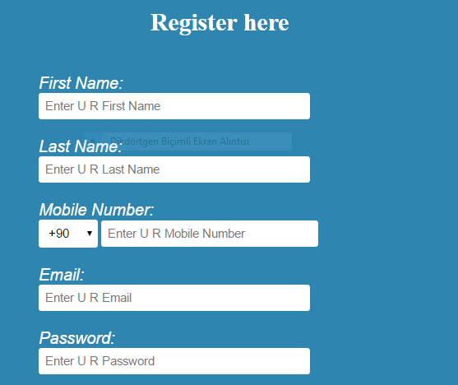

Code regist

html>

<head>

<title>Sent</title>

</head>

<body>

<style>

body{

background-image: url(ABD.jpg);

background-size:100% 700px;

background-repeat: no-repeat;

}

</style>

<label>First Name:</label>

<input type="text" name="Fname" id="name"

placeholder="Enter U R First Name"><br><br>

<label> Last Name:</label>

<input type="text" name="name" id="name"

placeholder="Enter U R last name"><br><br>

<input type="file" name="hande" id="ayse">

</body>

</html>

Sent file

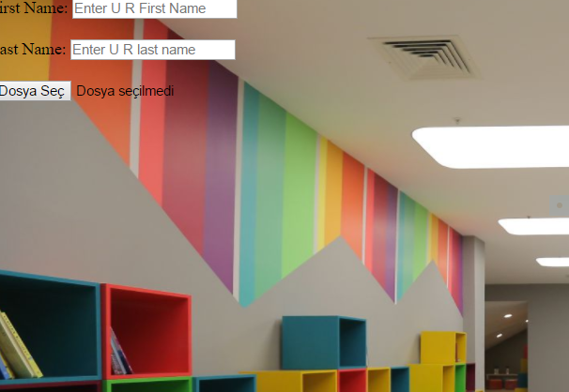

Sent code

<style>

body{

background-image: url(ABD.jpg);

background-size:100% 700px;

background-repeat: no-repeat;

}

</style>

<label>First Name:</label>

<input type="text" name="Fname" id="name"

placeholder="Enter U R First Name"><br><br>

<label> Last Name:</label>

<input type="text" name="name" id="name"

placeholder="Enter U R last name"><br><br>

AMAC

.Girilen stringlerin benzerlik oranını bulma

.Kullanıcını rahat kullanabileceği arayuz gerçekleştirmek.

